Math 1 Name ________________________

**3-6 Graphing Systems of Linear Inequalities** Date________

* *I can graph a system of inequalities and determine if a coordinate is a viable solution.*

Graph the system of inequalities.

1.  2. 

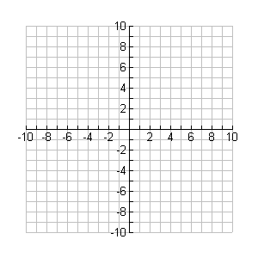 

Is the point (3, 4) a viable solution? _____ Is the point (-6, 4) a viable solution? _____

Is the point (6, -5) a viable solution? _____ Is the point (8, 5) a viable solution? _____

3.  4. 

(NOTE: these are equations)



Is the point (6, 3) a viable solution? _____ Is the point (4, 0) a viable solution? _____

Is the point (4, 0) a viable solution? _____ Is the point (-1, -2) a viable solution? _____

Is the point (0, 4) a viable solution? _____

5. 



Name a point that is viable to the system. _________

Name a point that is NOT viable to the system. _________

6. 



Name a point that is viable to the system. _________

Name a point that is NOT viable to the system. _________